1-Test Scenario (Test Condition)
How to write a Test Case - start at 0:00
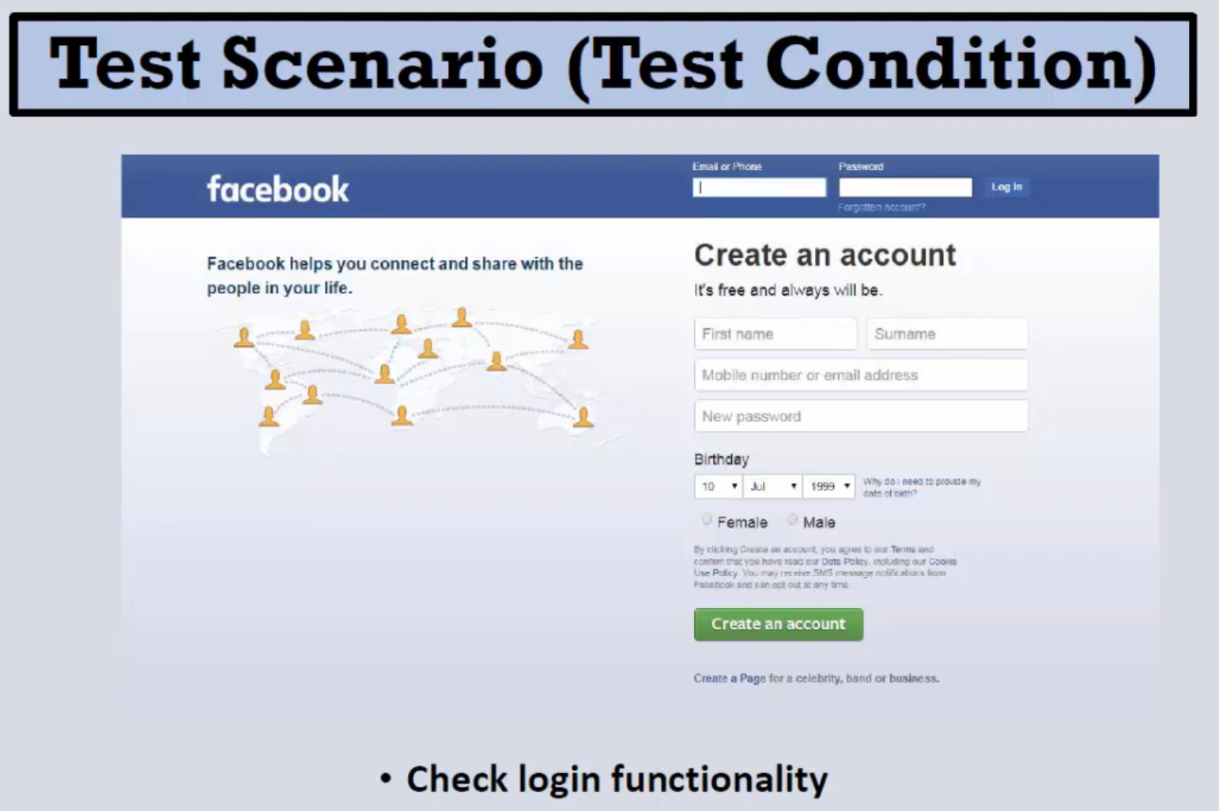

2-Test Case
How to write a Test Case - start at 0:21
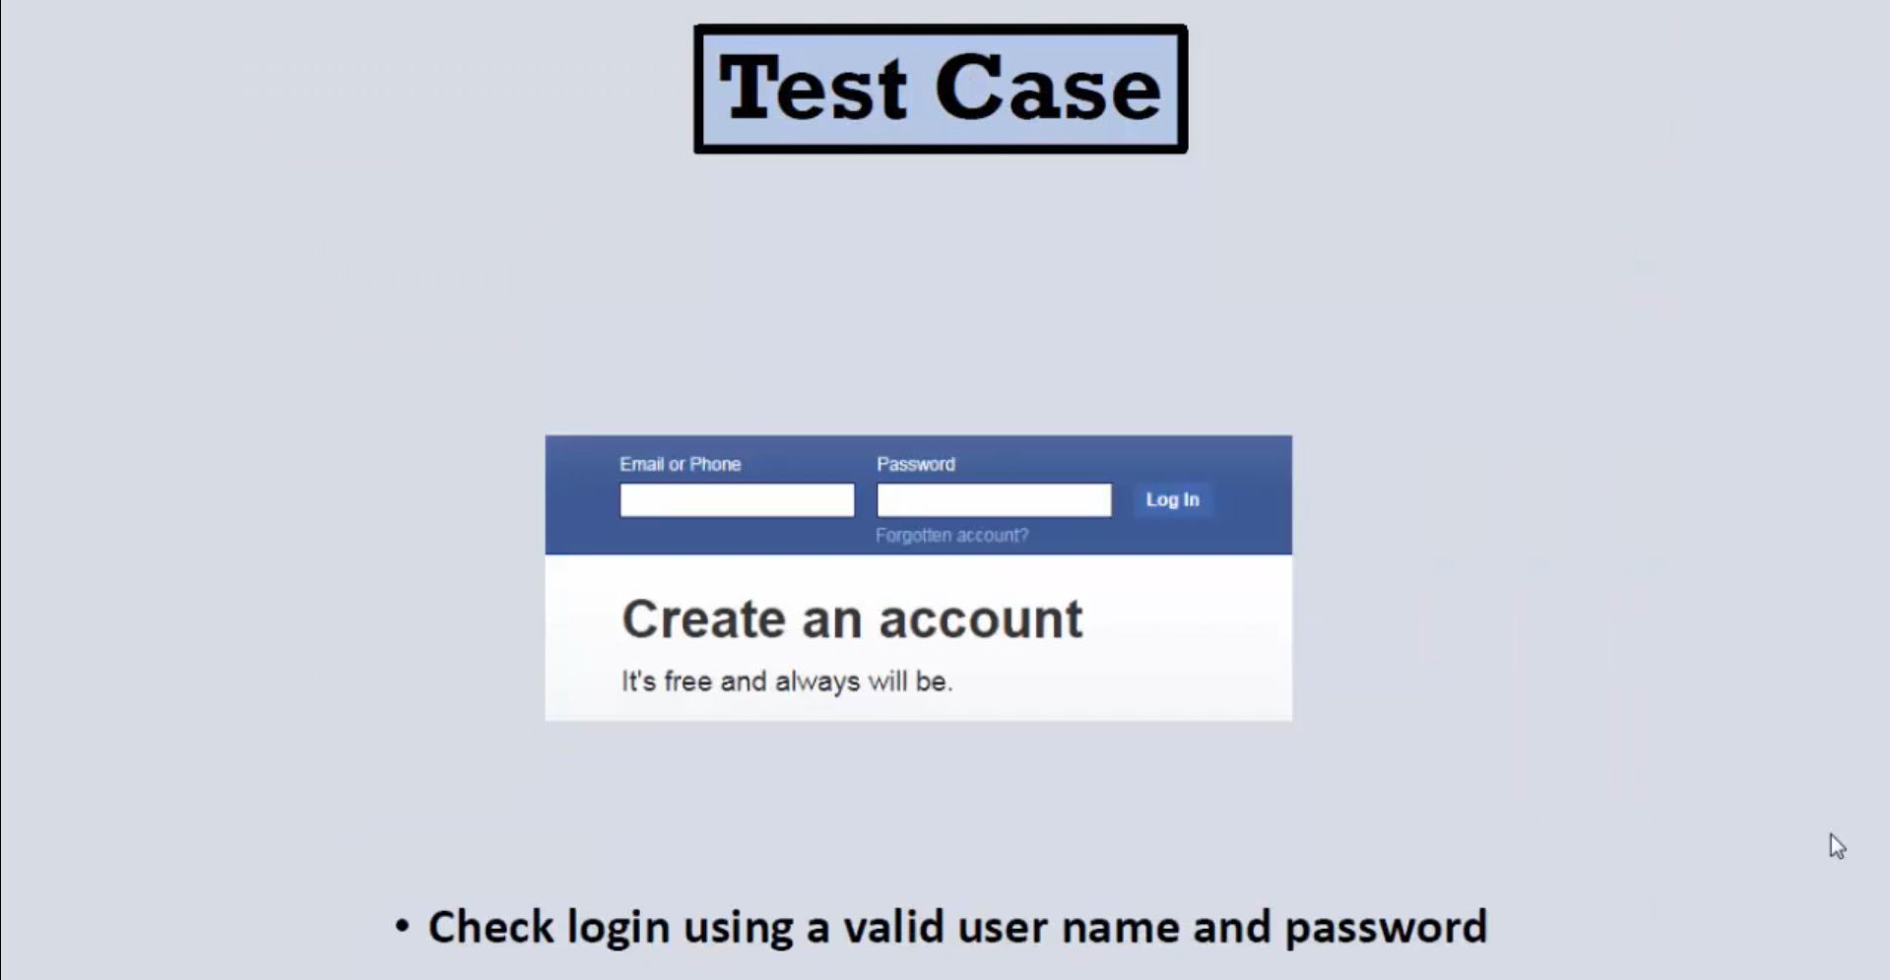

3-Test Data
How to write a Test Case - start at 0:29
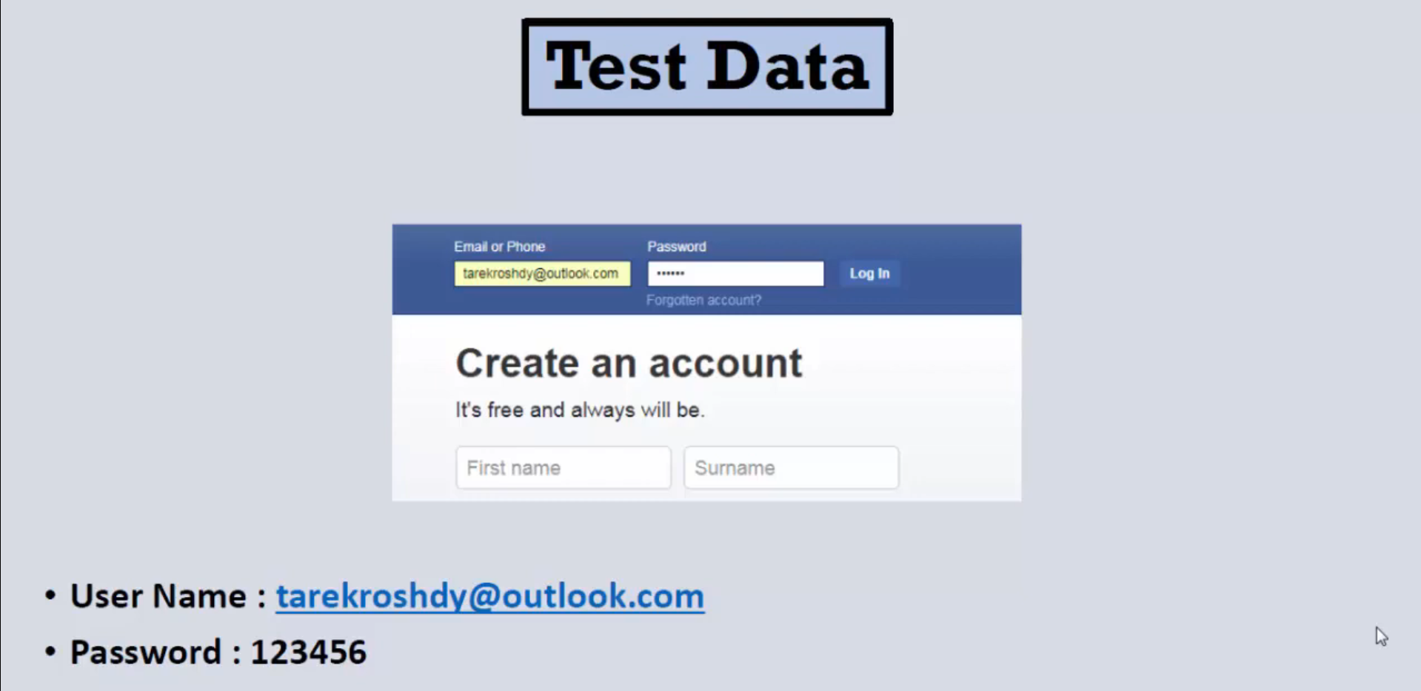

4-Expected Result
How to write a Test Case - start at 0:38
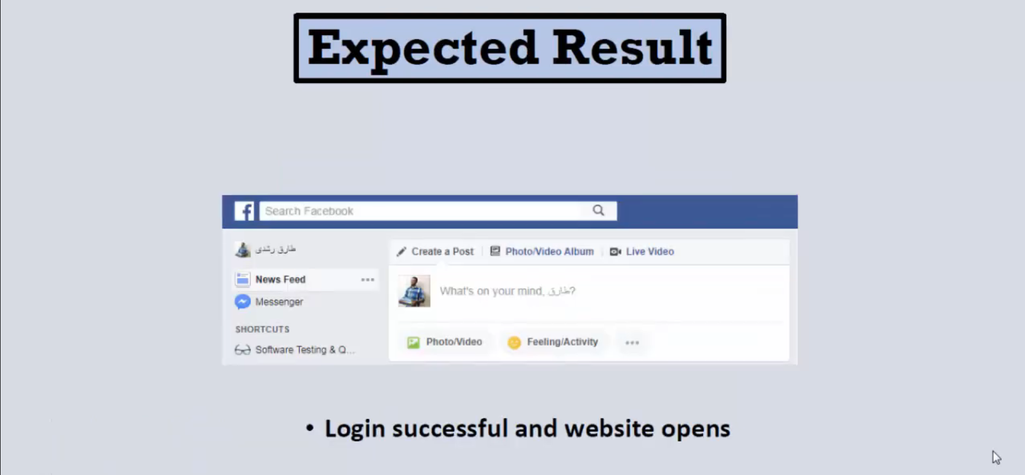

5-Test Steps
How to write a Test Case - start at 0:54
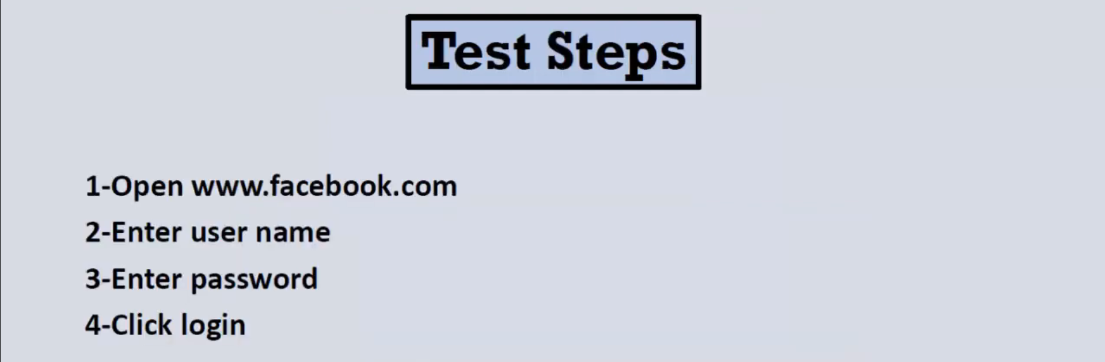

6-Precondition
How to write a Test Case - start at 1:13
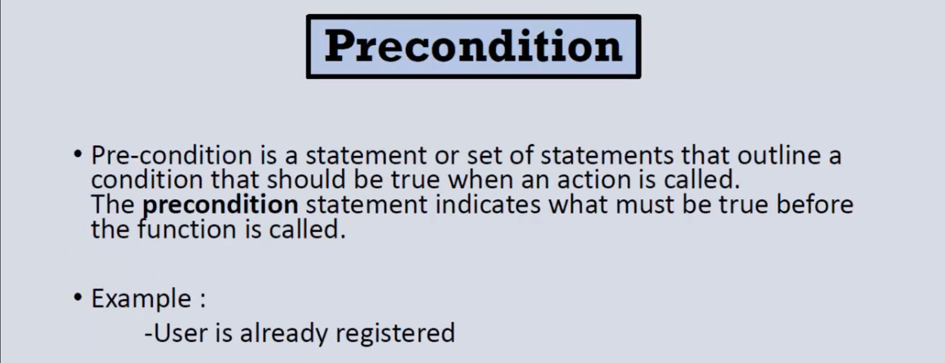

7-Postcondition
How to write a Test Case - start at 1:39
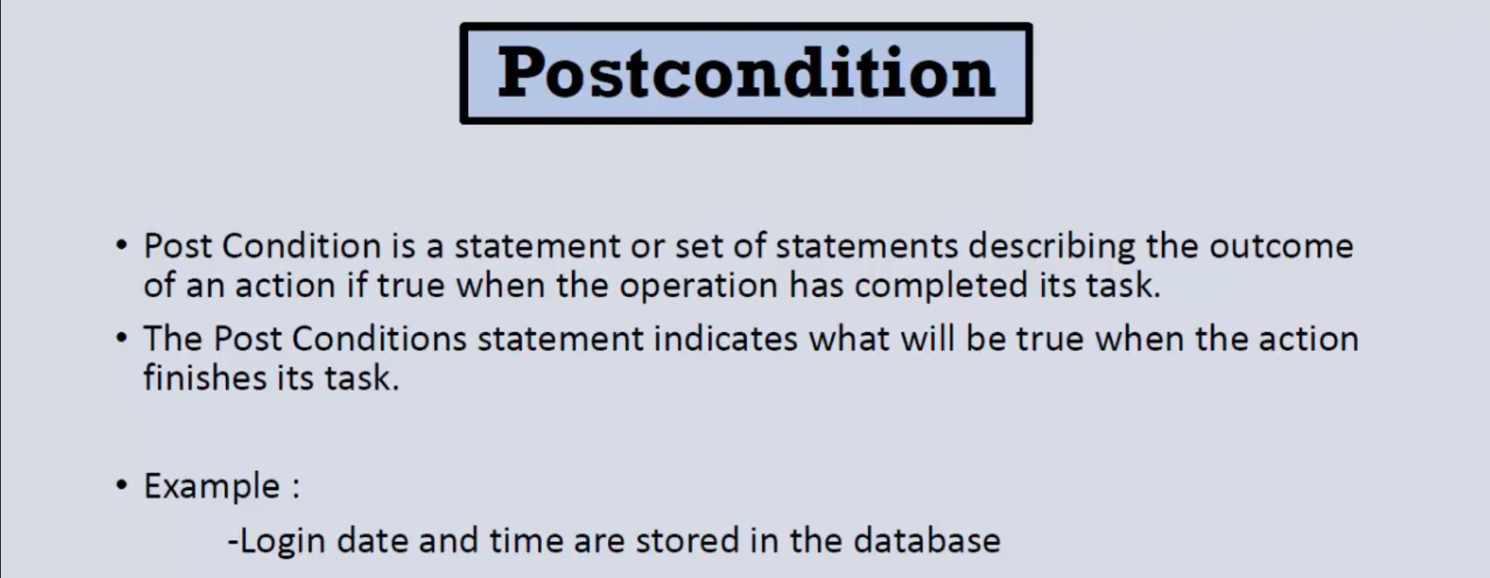

8-Test Case Example
How to write a Test Case - start at 2:12
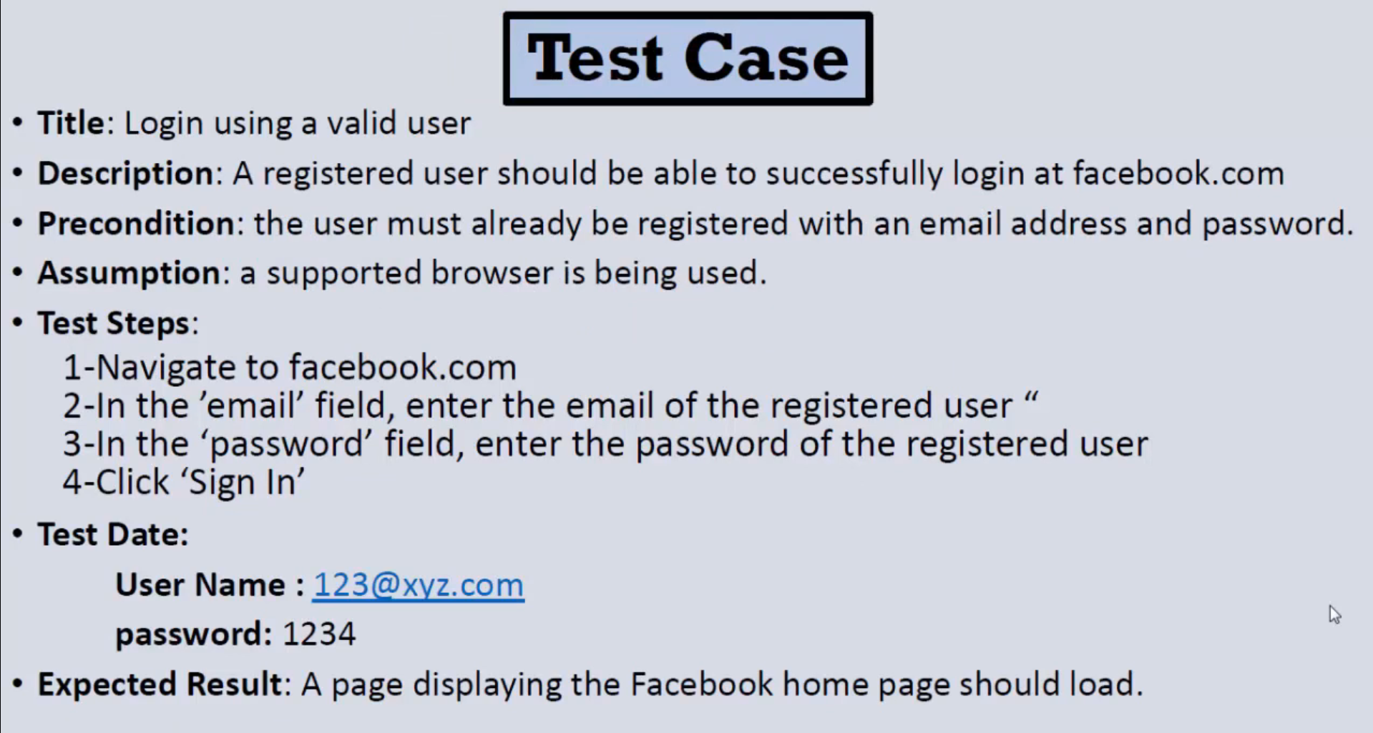

9-Test Case Example in Excel
How to write a Test Case - start at 3:01
